Punnett Squares: Codominance and Incomplete Dominance
Created by Patrick Haney

I created these practice sheets to reinforce my biology students understanding of codominance and incomplete dominance. These worksheets can be used during any Punnett square unit to help students, and they work well in tandem with the rest of my Punnett square Power Points, notes, and worksheets which are also available.
Punnett Square PowerPoint
Punnett Square Student Notes
Dihybrid Crosses PowerPoint
Dihybrid Crosses Student Notes
Genotypes and Punnett Square Practice

Are You Having Trouble Viewing the Documents?
I use the Microsoft 2007 True Type font Calibri in most of my lessons. If these lessons seem to be jumbled and incorrectly formatted, it is because you have an older version of Word and your computer has substituted a larger font (probably Arial) instead of Calibri. To fix this, simply download PowerPoint Viewer 2007 from Microsoft. This is a legitimate, free download from Microsoft and it allows all Microsoft Office applications to view the 2007 True Type fonts. The link below will take you directly to the PowerPoint Viewer download page. If you have further problems, please contact me through Teachers Pay Teachers and I will provide you with a correctly formatted pdf document at no additional charge.

PowerPoint Viewer 2007

Name: _______________________________ Date: _______________ Period: _____

Codominance: Predicting Blood Types

Complete the Punnett squares based on the information in the pictures, and then use the Punnett squares to answer the questions.

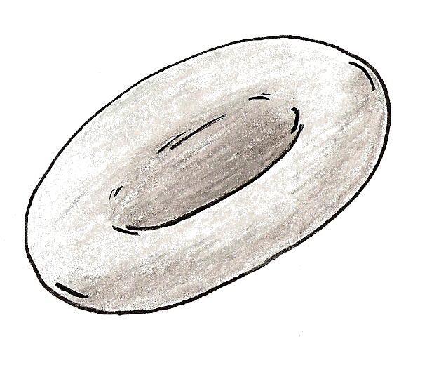

A

B

AB

O
Key:

Phenotype:

Genotype: I^{A}I^{A} or I^{A}i I^{B}I^{B} or I^{B}i I^{A}I^{B} ii

I^{A}I^{A} × I^{B}i

I^{A}i × I^{A}i

I^{A}I^{B} × ii

ii × I^{B}i
1. What percentage of the offspring will have the type A blood phenotype? __________

2. What percentage of the offspring will have the type AB blood phenotype? __________

3. What percentage of the offspring will have the type O blood phenotype? __________

4. What percentage of the offspring will have a homozygous genotype for type A blood? __________

5. What percentage of the offspring will have the type A blood phenotype? __________

6. What percentage of the offspring will have a heterozygous genotype of any kind? __________

7. What percentage of the offspring will have a homozygous genotype for type O blood? __________

8. What percentage of the offspring will have the type B blood phenotype? __________

A

B

A

A

AB

O

B

O

AB

A

A

A

A

I^{A}I^{A} × I^{A}I^{B}

I^{A}i × I^{B}i

ii × I^{A}i

I^{A}I^{B} × I^{A}I^{B}
9. What percentage of the offspring will have the type AB blood phenotype? __________

10. What percentage of the offspring will have a homozygous genotype for type A blood? __________

11. What percentage of the offspring will have the type O blood phenotype? __________

12. What percentage of the offspring will have the type AB blood phenotype? __________

13. What percentage of the offspring will have a heterozygous genotype and a type A phenotype? __________

14. What percentage of the offspring will have the type O blood phenotype? __________

B

15. What percentage of the offspring will have a homozygous genotype for type B blood? __________

16. What percentage of the offspring will have the type AB blood phenotype? __________

AB

AB

I^{B}i × I^{B}i

I^{B}I^{B} × I^{A}i
17. What percentage of the offspring will have the type B blood phenotype? __________

18. What percentage of the offspring will have the type O blood phenotype? __________

B

B

19. What percentage of the offspring will have the type AB blood phenotype? __________

20. What percentage of the offspring will have the type B blood phenotype? __________

B

A

Name: _______________________________ Date: _______________ Period: _____

Incomplete Dominance: Pigments

Complete the Punnett squares based on the information in the pictures, and then use the Punnett squares to answer the questions.
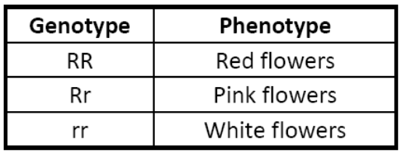
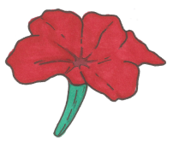
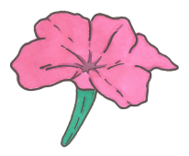
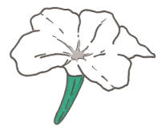

White
Red
Pink

Rr × rr

Rr × Rr

rr × RR

Rr × RR

1. What percentage of the offspring will have pink flowers? __________

2. What percentage of the offspring will have the red flowers? __________

5. What percentage of the offspring will have a heterozygous genotype? __________

6. What percentage of the offspring will have white flowers? __________

White
Red

3. What percentage of the offspring will have white flowers? __________

4. What percentage of the offspring will have pink flowers? __________

Pink
Pink

Red
White

7. What percentage of the offspring will have red flowers? __________

8. What will be the ratio of red flowers to pink flowers? __________

Red
Pink

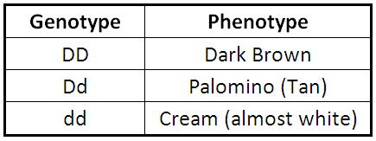
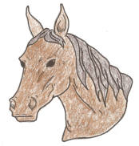
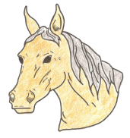
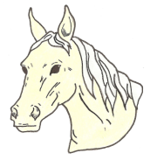
Cream
Dark
Brown
Palomino

DD × Dd

dd × Dd

Dd × Dd

DD × dd

7. What percentage of the offspring will have palomino coats? __________

8. What percentage of the offspring will have a homozygous genotype? __________

1. What percentage of the offspring will have dark brown coats? __________

2. What percentage of the offspring will have palomino coats? __________

Palomino
Dark Brown

3. What percentage of the offspring will have a homozygous genotype? __________

4. What will be the ratio of cream to palomino horse? ________

Palomino
Cream

Dd × dd

5. What percentage of the offspring will have cream coats? ________

6. What percentage of the offspring will have dark brown coats? ________

Palomino
Palomino

Cream
Dark Brown

9. What percentage of the offspring will have a heterozygous genotype? __________

10. What percentage of the offspring will have cream coats? __________

Cream
Palomino

Name: __________________________ Date: ________________ Period: ______
Practice: Codominance and Incomplete Dominance
Use the key below to answer the questions about the blood type Punnett squares.
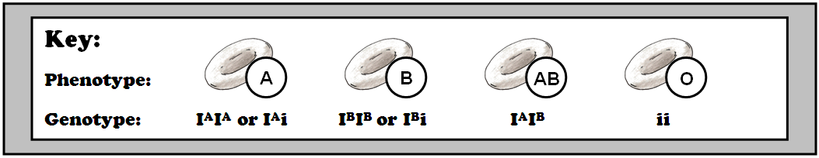

I^{B}i (♂) x I^{B}i (♀)
I^{A}i (♂) x I^{B}i (♀)
I^{A}i (♂) x I^{B}I^{B} (♀)
I^{A}I^{A} (♂) x I^{B}I^{B} (♀)
I^{A}I^{A} (♂) x ii (♀)
1. What percentage of offspring will have blood type AB? ________________
2. What percentage of offspring will have blood type O? ________________
3. What percentage of offspring will have blood type A? ________________
4. What percentage of offspring will have blood type AB? ________________
ii (♂) x I^{A}I^{B} (♀)
I^{A}i (♂) x I^{A}I^{B} (♀)

I^{A}I^{A} (♂) x I^{A}I^{B} (♀)

5. What percentage of offspring will have blood type A? ________________
6. What percentage of offspring will have blood type B? ________________
7. What percentage of offspring will have blood type AB? ________________
8. What percentage of offspring will have blood type A? ________________

I^{A}I^{B} (♂) x I^{A}I^{B} (♀)
ii (♂) x I^{A}i (♀)
I^{A}I^{A} (♂) x I^{B}i (♀)

I^{B}I^{B} (♂) x I^{A}I^{A} (♀)

9. What percentage of offspring will have blood type A? ________________
10. What percentage of offspring will have blood type AB? ________________
11. What percentage of offspring will have blood type O? ________________
12. What percentage of offspring will have blood type B? ________________

White
Red
Pink

Some flowers exhibit incomplete dominance as shown in the table above. Complete the Punnett squares and answer the questions for each.

Rr (♂) x Rr (♀)
1. What percentage of offspring will have red flowers?
_______________
Rr (♂) x rr (♀)
2. What percentage of offspring will have white flowers?
_______________
Rr (♂) x RR (♀)
3. What is the ratio of pink flowers to red flowers?

_______________

RR (♂) x rr (♀)
4. What percentage of offspring will have red flowers?
_______________
Rr (♂) x RR (♀)
5. What percentage of offspring will have pink flowers?
_______________

Rr (♂) x Rr (♀)
6. What percentage of offspring will have white flowers?
_______________

rr (♂) x Rr (♀)
7. What percentage of offspring will have white flowers?
_______________
rr (♂) x RR (♀)
8. What percentage of offspring will have pink flowers?
_______________

RR (♂) x Rr (♀)
9. What percentage of offspring will have red flowers?
_______________

Define the term codominance in your own words. _______________________________
________________________________________________________________________
Define the term incomplete dominance in your own words. _______________________
________________________________________________________________________

