Build an Atom
1. Google PhET build an atom and click on the first link. Click on the button.
2. Explore the simulation with your partner. Be sure to click on everything.
3. When Ms. Hawkins says it is time to start:
- Click on the reset all button.
- Open the boxes called Net Charge and Mass number
- These boxes and the periodic table box will help you fill in the data needed below.

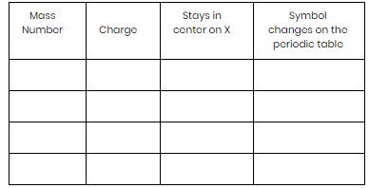
4. Experiment by putting some protons into the nucleus of the atom (on the X).
Fill in the table to the right to keep track of what you are learning about protons.
When you finish, put the protons back into the bowl.

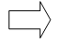

5. Experiment by putting some neutrons into the nucleus of the atom (on the X).
Fill in the table to the right to keep track of what you are learning about protons.
When you finish, put the protons back into the bowl.

6. Experiment by putting 10 electrons into the nucleus of the atom (on the X).
Fill in the table to the right to keep track of what you are learning about protons.
When you finish, put the protons back into the bowl.

Time to apply your understanding of the atom…

7. Put 3 protons into nucleus of the atom. Fill in the following:
Name of atom:_______________ atom or ion? ______________ net charge______________

8. Put 1 neutron into the nucleus of the atom.
Name of atom:_______________ atom or ion? ______________ net charge ______________

9. Put another neutron into the nucleus. What changes? __________________________________________
_______________________________________________________________________________________.

10. Put one more neutron into the nucleus. What do you notice? ____________________________________
_______________________________________________________________________________________.

11. Now add three electrons. How many electrons are in the inner circle? _____________ How many are in the outer circle? ­­­­­_______________ What is the net charge? ________________

12. Add three more electrons. How many electrons are in the inner circle? ____________ How many are in the outer circle? _______________ What is the net charge? ________________

13. Add the rest of the electrons. How many electrons are in the inner circle? __________ How many are in the outer circle? __________ What is the net charge? __________________

Decide how you will build a neutral atom that is stable. Practice making atoms using your ideas. Draw and label four different atoms that you created below.

Name of atom__________________  Number of protons______________  Number of neutrons_____________  Number of electrons____________ | Name of atom__________________  Number of protons______________  Number of neutrons_____________  Number of electrons____________
Name of atom__________________  Number of protons______________  Number of neutrons_____________  Number of electrons____________ | Name of atom__________________  Number of protons______________  Number of neutrons_____________  Number of electrons____________

